**Case Study API Documentation:**

* This application developed using Java
* Used MySQL for data persistence

1. **API for Fetch-New:**

This API will return the JSON as mentioned in response schema which has been extracted from Shopify Webservices and persisted in MySQL Database.

<http://localhost:8080/vajroservice/ProductList?mode=fetch-new>

1. **API for Fetch-Quick:**

This API will return the JSON as mentioned in response schema which has been extracted from Database.

<http://localhost:8080/vajroservice/ProductList?mode=fetch-quick>

1. **API for Refresh:**

This API will access the Variant WS and update the price & inventory_quantity column with latest data and return the JSON as mentioned in response schema. We can add needed products in below URL

<http://localhost:8080/vajroservice/ProductList?mode=refresh&prodIdList=6989519814862,6989520142542>

**Database Schema Info:**

Below are the tables which are created from/for our application.

* Variants table product_id column is foreign key for id column of Products table.
* Images table product_id column is foreign key for id column of Products table.

1. **Products Table:**

Primary Key Column: id

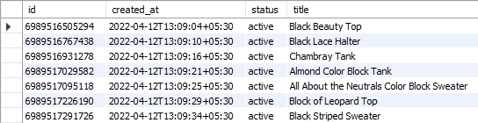

1. **Variants Table**

Primary Key Column: id & product_id

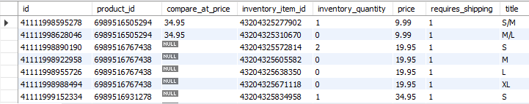

1. **Images Table**

Primary Key Column: id & product_id

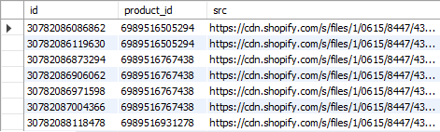

1. **Shop_Info Table**



1. **Product_Count Table**

